Demand: Guided Notes
-The Basics of Demand
-Economists study ______________:
–A market is any place where people come together to _____ and _____ goods or services.
-“Demand” - the willingness ______ ability of consumers to buy a good or service at a specific period of time
–________________: ready to buy a good or service
–________________: having the means to buy the good or service
-The Law of Demand
-The quantity demanded varies ______________ with price, other things constant (a.k.a. Price Effect)
________ Price = ________ Quantity demanded
________ Price = ________ Quantity demanded
-The Demand Schedule and Curve
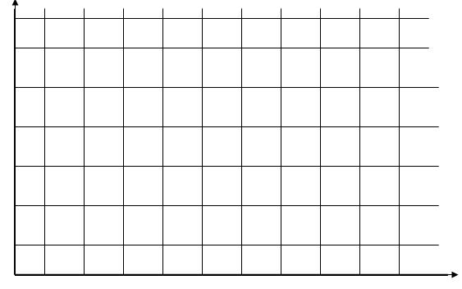
-A ____________ is a table that lists the quantity of a good that a person will purchase at each price. This is the STORY.
-The vertical axis ALWAYS shows ___________.
-The horizontal axis ALWAYS shows _____________________________.
- The D______________ slopes D___________________

-What is the difference between demand and quantity demanded?
-Demand is a ______________(the story) or __________________ (the picture)
-Quantity demanded refers to how many ___________ will be demanded at a particular ______________.

-Movement Along a Demand Curve Versus a Shift of the Curve
-A ______________ in _____________ creates a change in the quantity demanded, other things constant.
-This causes movement ALONG the demand curve.
-A ______________ in one of the ___________________ of demand causes a change in demand.
-This causes a SHIFT of a demand curve

